**PROJECT REPORT TEMPLATE**

**1. INTRODUCTION**

**1.1 OVERVIEW**

Estimating business expenses is an important step in determining how much money you need to start and keep your business running without encountering cash flow problems.

**1.2 PURPOSE**

Estimates are documents that provide approximate costs for a project. Small businesses create them for potential clients so both parties are clear on the ins and outs of a project before it starts. Fresh Books has an estimates feature that help you build an estimate quickly and easily

**2. PROBLEM DEFINITION & DESIGN THINKING**

**2.1 EMPATHY MAP**

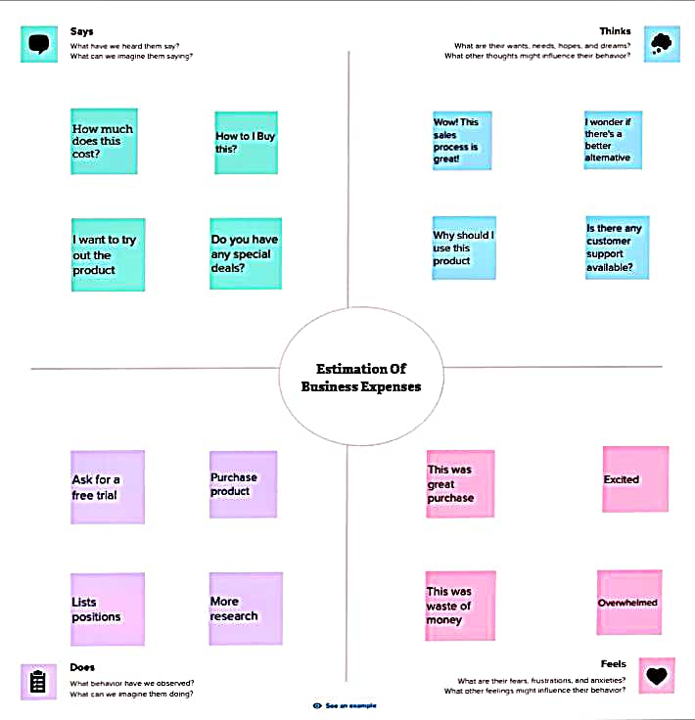

**2.2 IDEATION & BRAINSTROMING MAP**

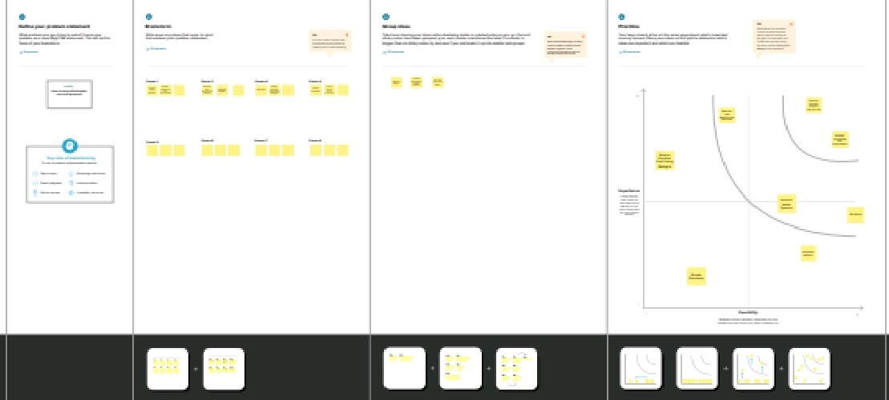

**3. RESULT**

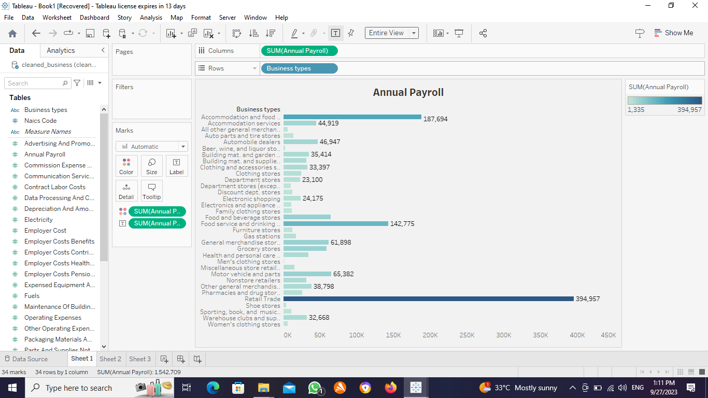

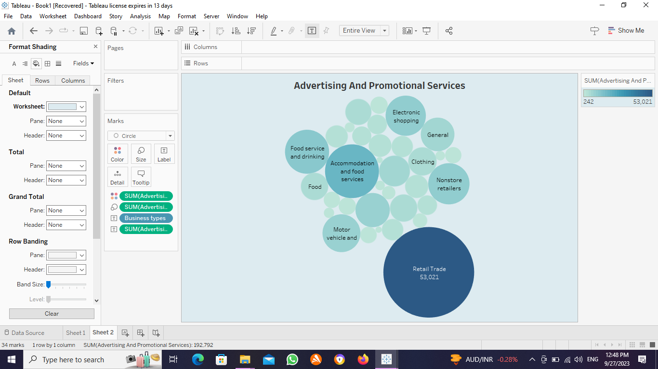

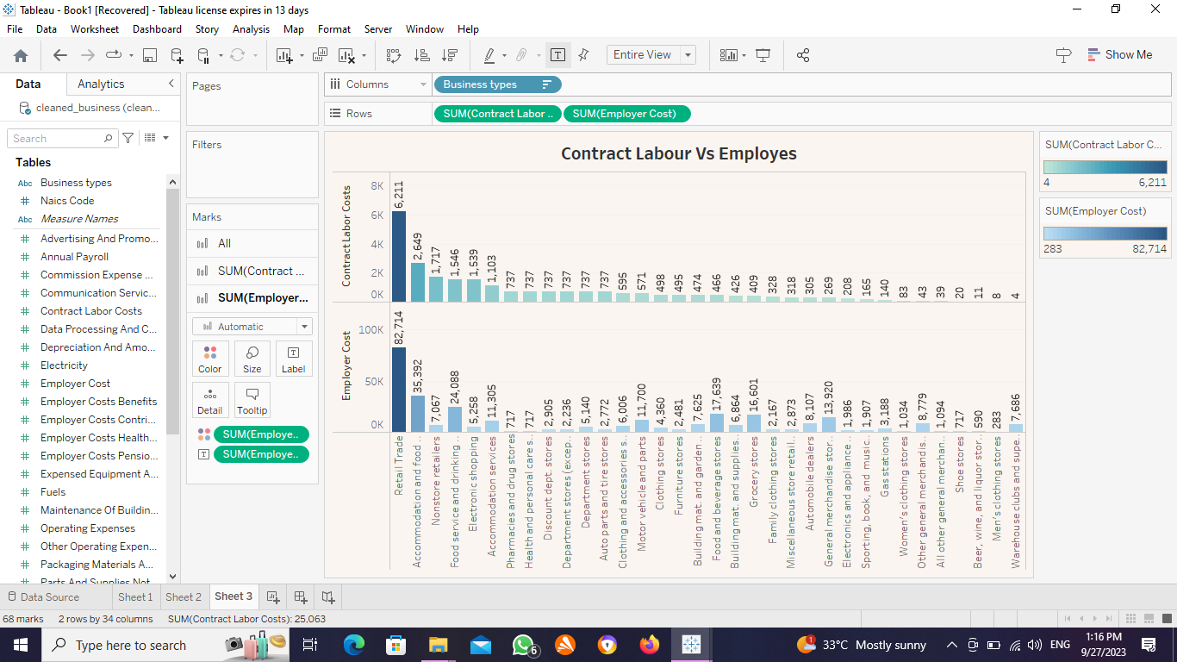

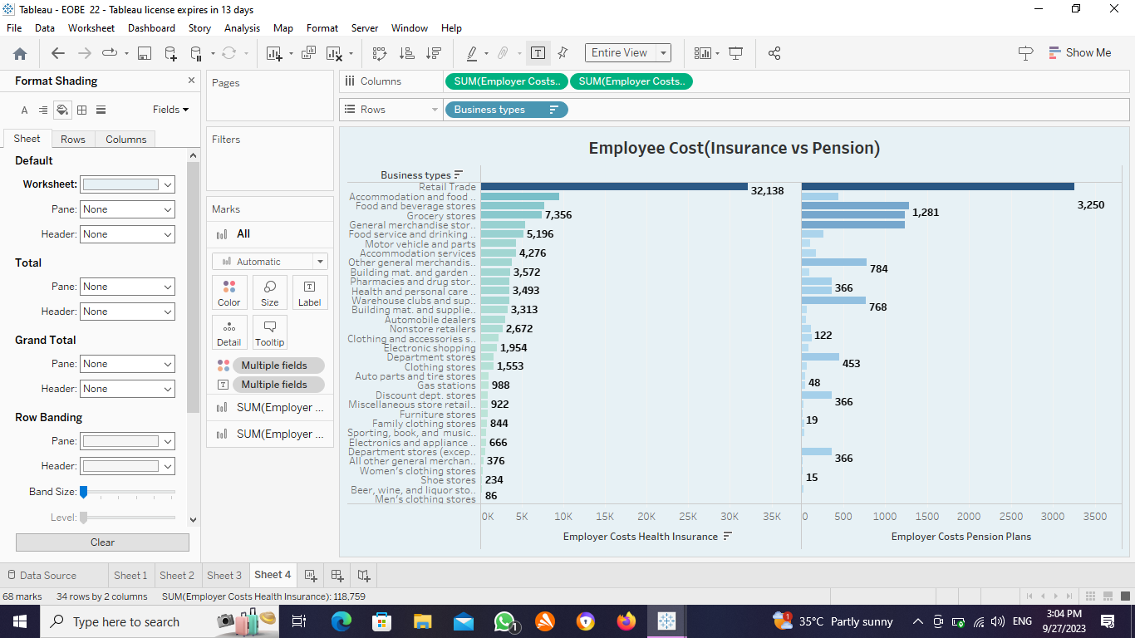

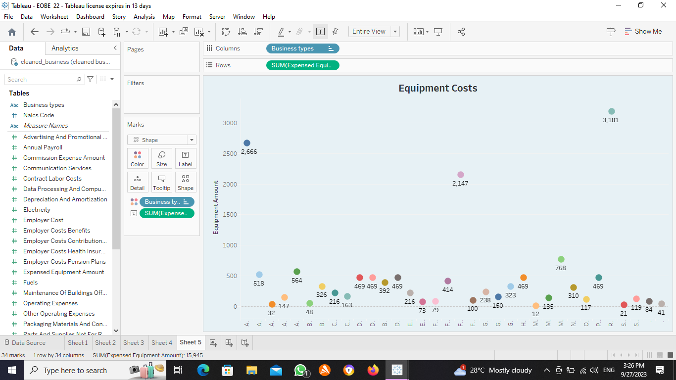

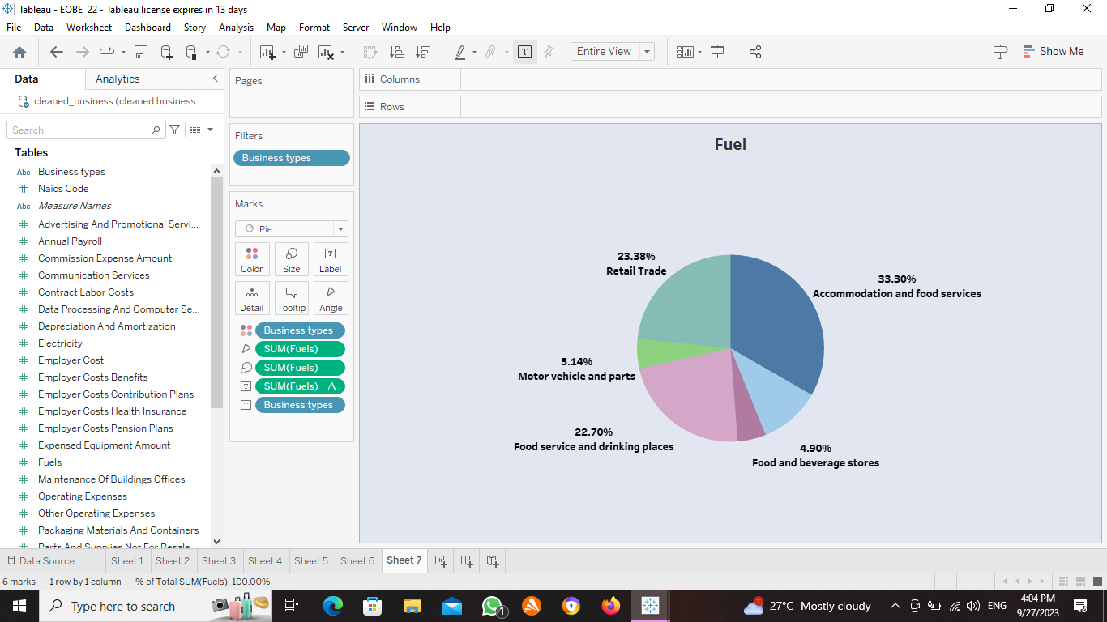

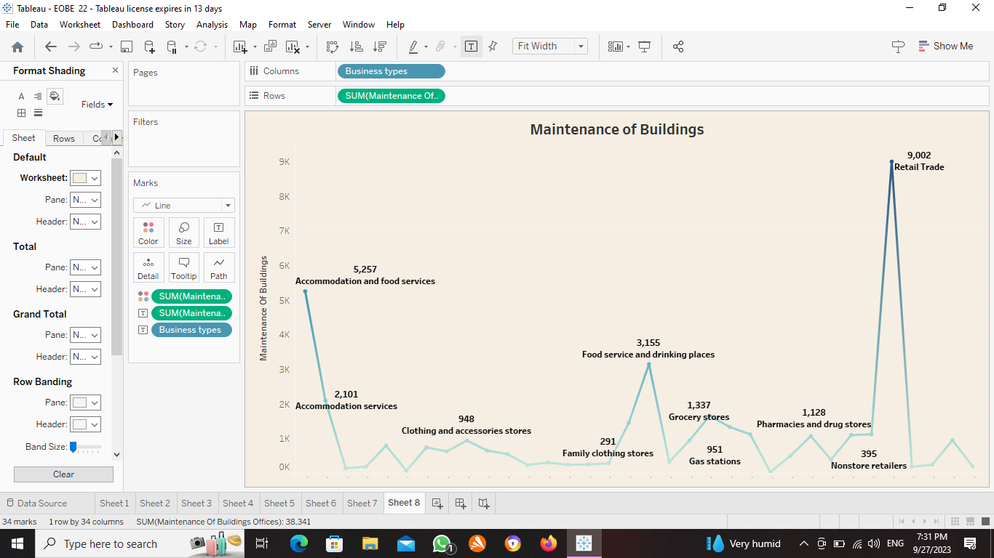

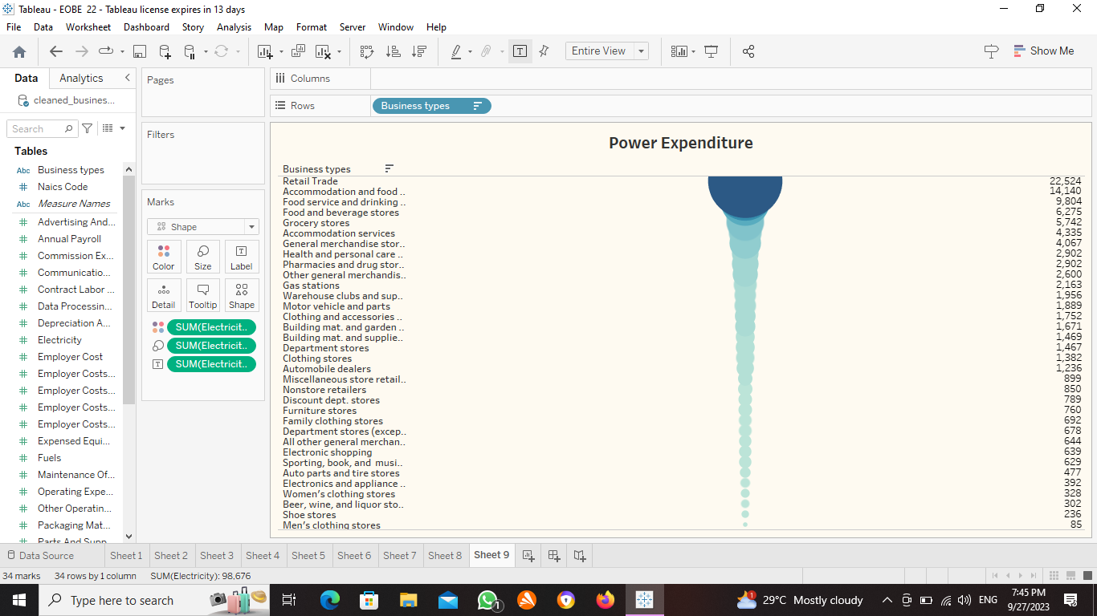

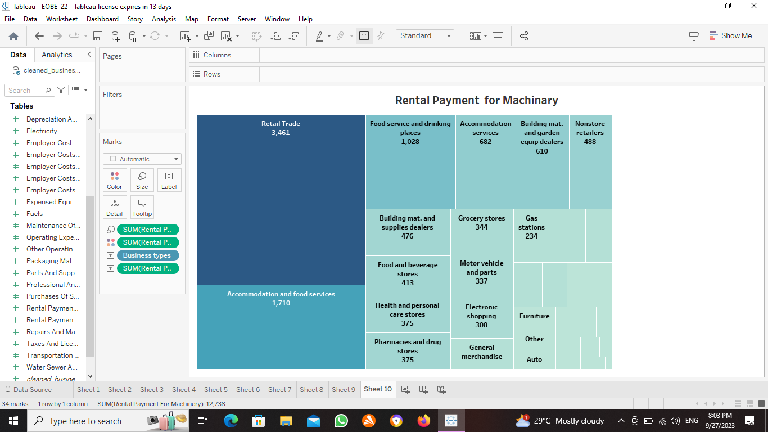



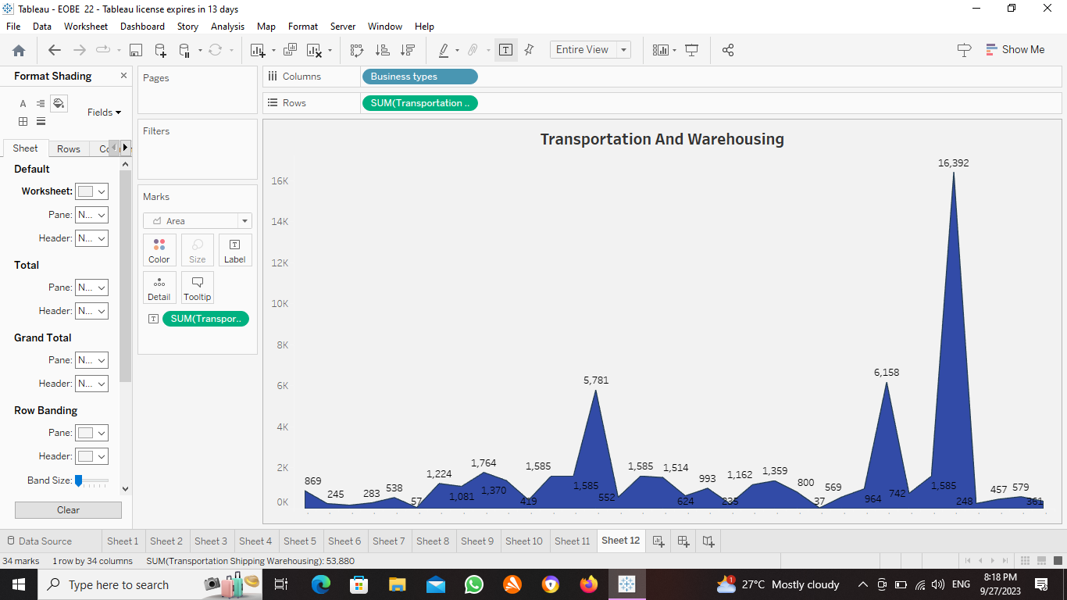

**4. ADVANTAGES & DISADVANTAGES**

**ADVANTAGES:**

Estimation provides a structured plan leading to better decision making and goal achievements.

The seniors of an organization are responsible to frame a estimation plan resulting in effective handling of expenses. A good plan can help in the more judicious use of resources as well as control over financial expenses.

**DISADVANTAGES:**

Estimation plan is not open to the opinions of all the employees which may turn out to be de-motivating for them some times.

There is a constant change take place in the industry or market. Hence the framed plan may not be as worthy as it may appear in the beginning.

**5. APPLICATIONS**

Estimation of business expenses analysis includes forming policy decisions, optimizing estimating strategies and enhancing overall saving plans.

**6**. **CONCLUSION**

In conclusion, estimation of business expenses analysis is a critical tool for informed decision-making, sustainable estimating practices and investment security.

**7. FUTURE SCOPE**

Expenses estimation in project management is the process of forecasting the financial and other resources needed to complete a project within a defined scope.